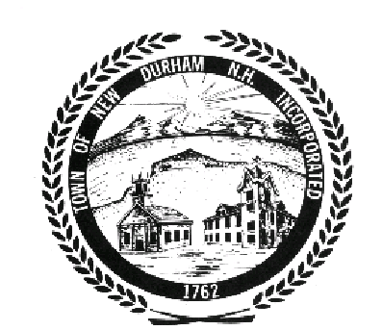

BUDGET COMMITTEE

PUBLIC MEETING AGENDA
October 28th, 2009

Time: 7:00 PM
Place: New Durham Town Hall

Joint Meeting with Board of Selectmen for discussion of Budgetary goals and objectives for 2010

(i) Administrative Recap
- Actions to date provided to Department Heads in preparation of their budgets
- Budget Accomplishments completed in 2009
- Budget Accomplishments not completed in 2009

(ii) Capital Improvement Plan Review
- Any realignment of priorities?
- Can the suggested $$$ savings be adjusted lower without harming future acquisitions?

(iii) Revenues / Valuations
- Estimate/Valuation Discussion & how estimates/valuations are derived

(iv) Compensation
- Opinions as to prevailing economic climate

(v) Any Other Business

(vi) Adjournment

